CSCIE-15 Assignment 2

Mehmet F Erten

Africa, Selected Madagascar flag, selected Population 20-30 Millions, Language French, Capital “A” letter

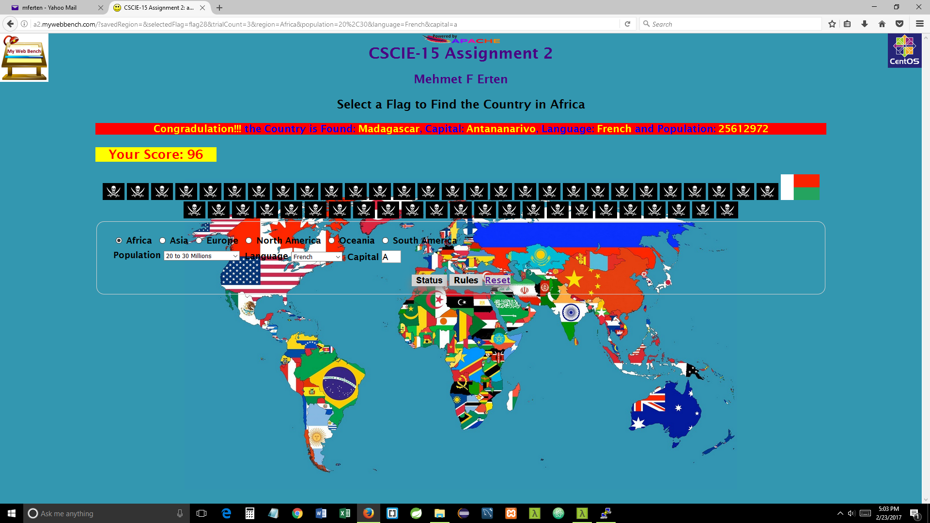

Asia, selected India, selected Population 1-2 Billions, selected Language English after seeing China and India

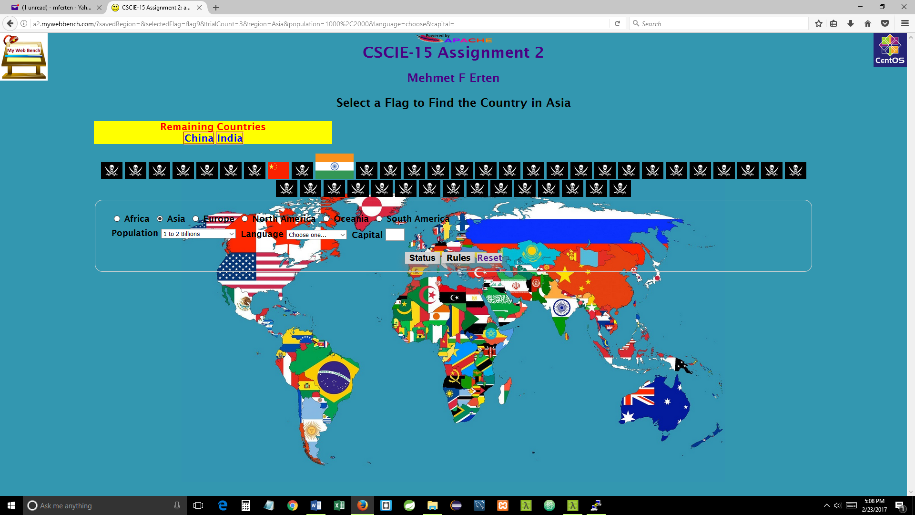

Europe, selected Georgia Flag (not knowing it is Georgia), selected Population 1-5 Millions, Selected Language from top to the bottom up until I got the Congratulation message.

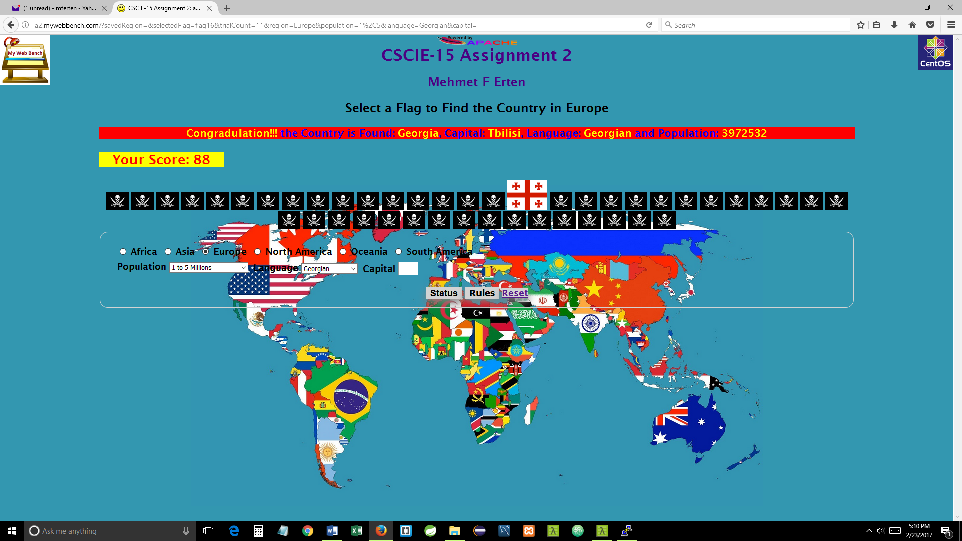

North America, either Population 300-500 Millions or Capital letter “W” shows Congratulation message.

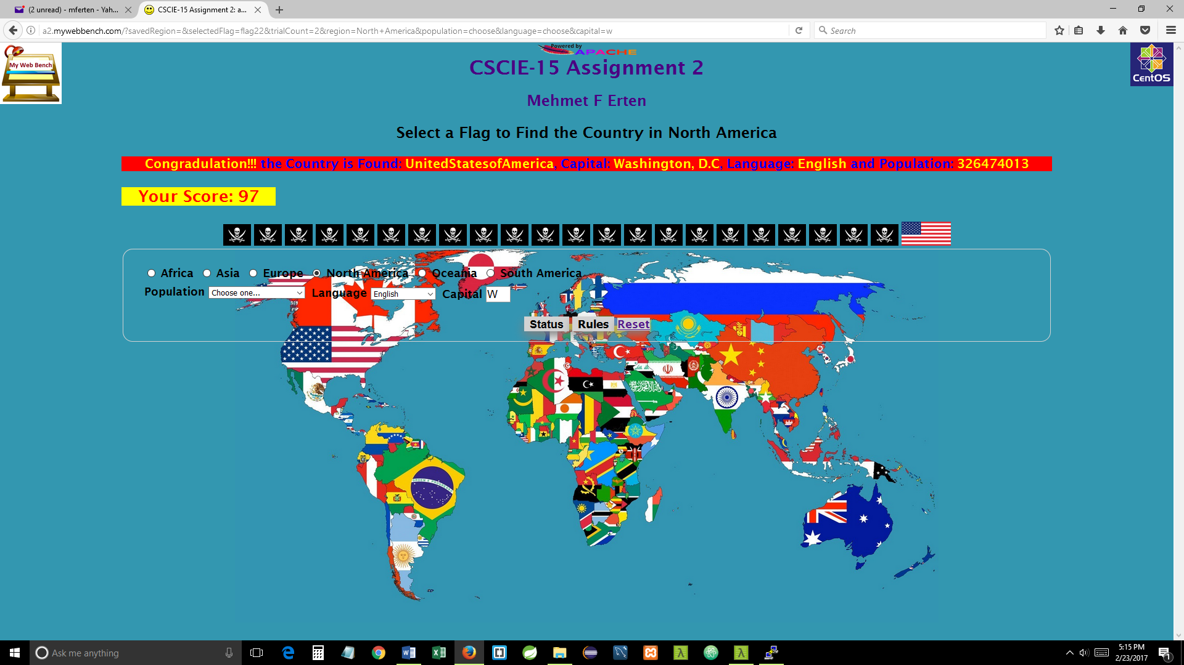

Oceania, selected Population 0-1 Million, selected Language Bislama from top to the bottom up until I got Congratulation message

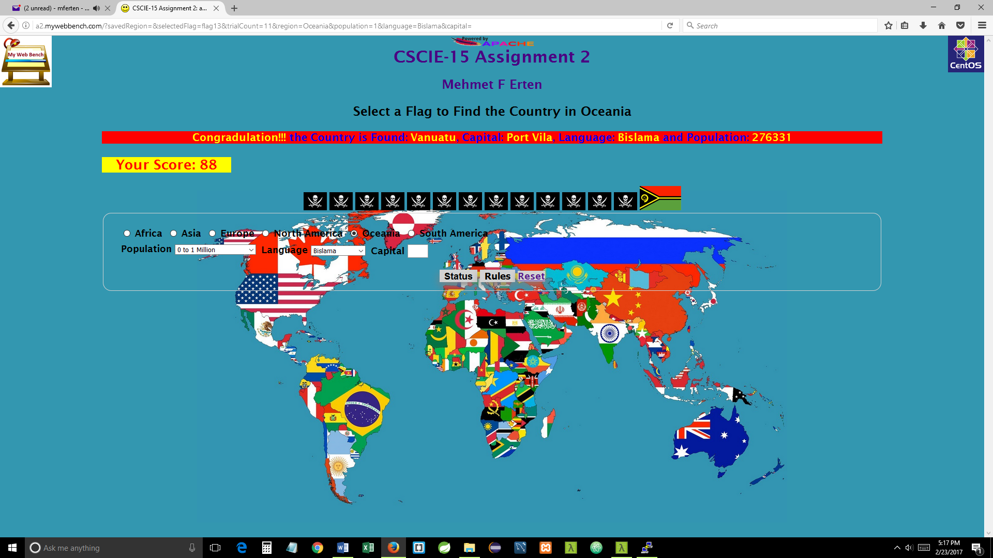

South America, a tie between Argentina and Colombia with the current application.

Both has 40-50 Million population; both has a Capital city which its name starts with the letter “B”; both speaks Spanish.

